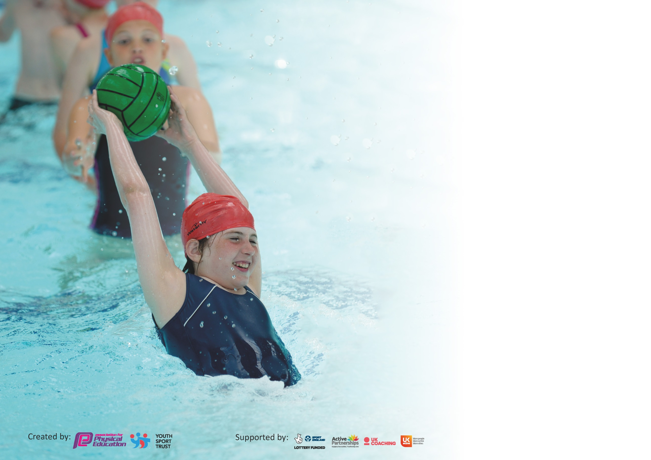

It is important that your grant is used effectively and based on school need. The Education Inspection Framework (Ofsted 2019 p64) makes clear there will be a focus on ‘whether leaders and those responsible for governors all understand their respective roles and perform these in a way that enhances the effectiveness of the school’.

Under the Quality of Education criteria (p41) inspectors consider the extent to which schools can articulate their curriculum (INTENT), construct their curriculum (IMPLEMENTATION) and demonstrate the outcomes which result (IMPACT).

To assist schools with common transferable language this template has been developed to utilise the same three headings which should make your plans easily transferable between working documents.

Schools must use the funding to make additional and sustainable improvements to the quality of Physical Education, School Sport and Physical Activity (PESSPA) they offer. This means that you should
use the Primary PE and Sport Premium to:

- Develop or add to the PESSPA activities that your school already offer
- Build capacity and capability within the school to ensure that improvements made now will benefit pupils joining the school in future years

Please visit gov.uk for the revised DfE guidance including the 5 key indicators across which schools should demonstrate an improvement. This document will help you to review your provision and to report your spend. DfE encourages schools to use this template as an effective way of meeting the reporting requirements of the Primary PE and Sport Premium.

We recommend you start by reflecting on the impact of current provision and reviewing the previous spend.

Schools are required to publish details of how they spend this funding as well as on the impact it has on pupils’ PE and sport participation and attainment by the end of the summer term or by 31st July 2020 at the latest.

We recommend regularly updating the table and publishing it on your website throughout the year. This evidences your ongoing self-evaluation of how you are using the funding to secure maximum, sustainable impact. Final copy must be posted on your website by the end of the academic year and no later than the 31st July 2020. To see an example of how to complete the table please click HERE.

Support for review and reflection - considering the 5 key indicators from DfE, what development needs are a priority for your setting and your pupils now and why? Use the space below to reflect on previous spend and key achievements and areas for development.

St Paulinus Sports Premium Funding - a summary

Our identified priorities for the Sports Premium for 2019/20 at St Paulinus are:

- To increase pupil participation in extra-curricular sports clubs
- Continue to develop the quality of teaching of PE curriculum for teachers
- Utilise the school’s own teaching of PE as a model of good practice
- Increase participation and success in intra and inter-school competition through releasing staff and taking part in local sporting partnerships/competitions (including football, cricket, tag rugby, cross country, netball, bike ability, swimming and rounders)

Events entered from 2019/2020:
Level 1 | Level 2 | Kirklees

Sport | Event/Competition | Year Group | Organised by
Fun Run | St Paulinus | Whole School | St Paulinus
Multi skills | St Paulinus | KS1 | SJF/ Gail Gerrard
Orienteering | SJF event | KS2 | SJF sports partnership
Athletics | SJF Event | Year 3 & 4 | SJF sports partnership
Dance Mats | St Paulinus | Whole school | SJF sports partnership
Balance Bikes | Bikeability training | KS1 & EYU | SGO/ PE co-ordinator
Cycling | Bikeability training | Upper KS2 | SGO/ PE co-ordinator

Key achievements to date until July 2020: | Areas for further improvement and baseline evidence of need:
September – March 2020  - A new range of sports available for all children of all age groups lunch time and afterschool clubs running; football, street dance, dodgeball, orienteering, bushcraft, gymnastics, dance, street dance, funky fitness, hockey, mindfulness yoga  - - PE display completed. Pupil voice displayed for clubs, sporting events. Intro for all sports leaders on display  - Project sport: Bush craft lessons for EYU and nursery, ball skills for KS1 and football for KS2.  - Orienteering for KS1 & 2 with Viv Barraclough  - Dance mats used in Autumn 2  - Multi skills for KS1 with Gail Gerrard – three sessions for EYU/ Year 1 and Year 2  - Huddersfield Giants leading rugby sessions in Autumn 2  - Sports coach sessions distributed evenly to all classes and staff members  - Dan Batty from Kaisen Sports to deliver gymnastics and dance cpd for KS1 and KS2 for Spring term.  - Breakfast club to give J. O’Donell CPD for skill based games/ fitness  - Dan Batty working alongside lunchtime supervisors to upskill their development of physical activities  - Balance bikes sessions for EYU, Year 1 and Year 2  - Bikeability for Year 5 pupils  - Young sports leader training 10.10.19  - 15 Young sports leaders from Year 6 set up and running lunch time activities in pairs across all year groups every lunchtime all providing a variety of sports/skills  - Sports crew have a register to target a different child each week to ensure every child has taken part in an activity.  July 2019  - Silver award gained in July 2019 from School Games  - Health week in Summer 2 in July 2019 organised for the whole school EYU-Year 6: Sports Day for EYU, KS1, KS2. A range of different sport coaching companies came in to lead sessions. A full week off timetable, completing the ‘daily mile’ in every class. Promoting healthy eating, living and a healthy mind. Incorporating active minutes into everyday learning.  - Level 1-Level 3 competitions accessed | - Monitoring of the teaching of Physical Development from Nursery – Year 6  - Access more level 3 sports  - Create a feedback sheet from staff questionnaires  - Create graphs from pupil questionnaires from year 1 -year 6 pupils  - Upskill St Paulinus Sports crew to attend and assist in outside sporting events  - Implement progression document

Meeting national curriculum requirements for swimming and water safety.
What percentage of your current Year 6 cohort swim competently, confidently and proficiently over a distance of at least 25 metres?  N.B. Even though your pupils may swim in another year please report on their attainment on leaving  primary school at the end of the summer term 2020. | 90%
What percentage of your current Year 6 cohort use a range of strokes effectively [for example, front crawl, backstroke and breaststroke]? | 7%
What percentage of your current Year 6 cohort perform safe self-rescue in different water-based situations? | 0%
Schools can choose to use the Primary PE and Sport Premium to provide additional provision for swimming but this must be for activity over and above the national curriculum requirements. Have you used it in this way? | Yes/No

Action Plan and Budget Tracking
Capture your intended annual spend against the 5 key indicators. Clarify the success criteria and evidence of impact that you intend to measure to evaluate for pupils today and for the future.

Academic Year: 2019/20 | Total fund allocated: £19,448 Total spent: £ 21,929 | Date Updated: 2.4.20
Key indicator 1: The engagement of all pupils in regular physical activity – Chief Medical Officer guidelines recommend that primary school pupils undertake at least 30 minutes of physical activity a day in school
Intent | Implementation |  | Impact
Your school focus should be clear what you want the pupils to know and be able to do and about  what they need to learn and to  consolidate through practice: | Make sure your actions to achieve are linked to your intentions: | Funding allocated: | Evidence of impact: what do pupils now know and what can they now do? What has changed?: | Sustainability and suggested next steps:
Ensure our pupils can swim at least  25 metres. | Use one of our teachers to support the swimming teachers. Teacher to attend the swimming course. Timetable the swimming teacher and identify target group/s. | KAL swimming  £11,149 | TBC | - Ensure target groups are identified and interventions are put in place  - Continue with this provision
Encourage pupils to have a healthy and active lifestyle at lunch and break times through structured play. | Sports coach from Kaisen sports, Projects sport and P.E lead to train and support our Sports Crew to organise and manage the equipment and the play. Daily rota introduced. Encouragement of pupils to participate using equipment, games and leadership. | Project sport  AT1 £1,728  AT2 £1,512  Sp1 £1296  Sp2 £1296  Kaisen sports – Spring term  £1350  Total £7,182 | Pupils are more active and engaged during lunchtime.  Increased numbers of pupils participating in structured play.  Improved interaction and behaviour at lunchtime. | - Intra and external competitions to be organised from sports/activites taken place on a lunch time  - Target children who enjoy competitions  - P.E lead and Kaisen Sports to have a discussion with leaders and staff regarding ideas, issues, organisation to ensure a smooth running and to maximise opportunities.  - Use pupil and staff questionnaires to evaluate next steps TBC
Ensure the school has sustainable high quality teaching and learning in P.E. | Timetable the specialist P.E. teachers to work alongside the teachers to teach 1-2 hours of P.E. lessons per week throughout the academic year | Sports coaches  £7182 | Specialist P.E. teacher worked alongside all teachers where possible  1-2 hours of P.E. delivered. | - Continue to employ specialist P.E. coaches to work alongside teachers.
Provide every pupil the opportunity to engage in physical activities and competitions through our lunch time and after-school program.  Provide every pupil the opportunity to engage in intra competitions linked to the P.E. curriculum. | P.E lead and coaches to identify and offer a range of sports and activities to all pupils. Focus on pupils not accessing opportunities in extra-curricular activity.  P.E lead to source and timetable the external coaches/clubs and inform parents where necessary.  Sports Crew and lunch time supervisors to assist with the activities delivered on a lunch time and P.E lead to assist with intra and external competitions.  P.E. lead to review current planning to ensure it provides the opportunity for each pupil to engage in intra competitions. | SJF partnership  £2448  Sports coaches  £7182  Orienteering  £840 Autumn | Sustain and build links with local community sport providers and clubs.  Involvement of a larger number of pupils in structured intra school sport.  Increase in skill level of participants and Young Leaders.  More pupils wanting to be involved in the inter sporting competitions and activities.  Increased pupil numbers in the school’s extra-curricular clubs.  Increased pupil motivation and enthusiasm for P.E  Enhanced a positive attitude and engagement in and towards sporting activities. | -Continue to sustain and build links with local community sport providers and clubs.  -Continue to upskill Sports crew, start from September 2020  -Update website regularly with sporting achievements  -Update P.E display to promote sporting achievements in and out of school
Increase the  active learning opportunities across the curriculum | P.E lead to share other active learning opportunities e.g. BBC supermovers, go noodle, cosmic yoga, Joe Wicks  Staff Meeting to share ideas and place the activities into their planning and regular routine | N/A | Active opportunities in EYU and KS1 are used more regularly when speaking to teachers  Children are more focused and ready to learn after having short active minute breaks | -Engage KS2 teachers to incorporate active minute breaks into their day  -Teachers to complete a ‘heat map’ showing areas of high and low activeness in lessons  -Research and share active ideas
Key indicator 2: The profile of PESSPA being raised across the school as a tool for whole school improvement
Intent | Implementation |  | Impact
Your school focus should be clear what you want the pupils to know and be able to do and about  what they need to learn and to  consolidate through practice: | Make sure your actions to achieve are linked to your intentions: | Funding allocated: | Evidence of impact: what do pupils now know and what can they now do? What has changed?: | Sustainability and suggested next steps:
Increase the active learning opportunities across the curriculum. | P.E. leader to share other active minute ideas  Lead active minute sessions for teachers to observe to gain ideas from- see how it can be balanced alongside their normal routine and within lessons, e.g. star jumps in maths when counting or doing times tables or active phonic lessons using hoops and bean bags to match the correct digraph etc | N/A | - Increased the engagement of pupils in regular physical activity in EYU and KS1  -Ideas from staff for active minutes to be used in daily routine | -Search and share new active learning ideas.  -Continue to implement ideas in EYU and KS1  -Engage KS2 teachers to incorporate active minute breaks into their day
Social media, newsletters to acknowledge and celebrate sporting events and achievements.  P.E display outside the hall showing curricular and extra-curricular opportunities, leadership and achievements.  School games award for pupils, visitors and parents to see. | P.E. lead to share achievements and P.E. opportunities in newsletters and the app when appropriate.  P.E lead to produce a display for parents, governors, pupils and staff to showcase our P.E. provision | Sports coaches  £7182  Orienteering  £840 Autumn  SJF partnership  £2448 | -P.E. activities visible to parents, school and the sports partnership.  School Games Silver Award 2018-19 | -Continue to celebrate individual, team, whole school achievements.
Continue to employ Sports Coaches to work alongside the P.E. teacher. | - Timetable the coaches to work alongside the teachers and the teaching assistants to assist with the activities delivered on a lunch time, after-school activities and competitions (where possible)  -Health week in Summer term to promote a range of different sports and teachers to discover and participate in new sports and develop their CPD | Sports coaches  £7182  Orienteering  £840 Autumn | - Adds to the provision of sports and activities we offer in school  -Contributed towards the engagement of pupils in regular physical activity  -Provided a broader experience of a range of activities  -Promoted healthier, happier and more confident children in physical activity  -promotion of well-being in children when taking part in team games and physical activities | -Set and promote standard for high quality P.E., School sport, participation and enjoyment.  -Continue with this provision.
Train a group of year 6 young sport leaders – ‘Sports crew’ and upskill their leadership skills | P.E lead to organise and provide the training for the young leaders and timetable their leadership opportunities.  Sports crew to attend young leaders training on 11.10  Sports crew meeting every Tuesday in Spring Term with P.E lead to develop their leadership skills and give ideas for their lunch time clubs, warm up’s, activities and cool down’s | Young leaders transport £100  Supply from KSS for KC on 11.10 £160 | Provided opportunities for pupils to lead and manage within PE.  Pupils are more active and engaged during lunchtime.  Increased numbers of pupils participating in structured play during lunch time.  Improved interaction and behaviour at lunchtime.  Sports crew gained valuable teamwork, resilience and character education for further education. Learnt the importance of physical activity, mutual respect and communication skills for P.E. | -Continue with this provision.  -Explore other leadership opportunities e.g. helping at partnership events

Key indicator 3: Increased confidence, knowledge and skills of all staff in teaching PE and sport
Intent | Implementation |  | Impact
Your school focus should be clear | Make sure your actions to | Funding | Evidence of impact: what do | Sustainability and suggested
what you want the pupils to know | achieve are linked to your | allocated: | pupils now know and what | next steps:
and be able to do and about | intentions: |  | can they now do? What has
what they need to learn and to |  |  | changed?:
consolidate through practice:
Hire in coaches to work alongside staff in the delivery of Dance and gymnastics (Kaisen sports) Football (Project Sport), Handball (Project Sport) Rugby (Huddersfield Giants), Orienteering (Viv Barraclough), SJF partnership (Mick Troop or Josh)  Continue to employ coaches to work alongside teachers to improve their practice and ensure the school has sustainable high quality teaching and learning in P.E. | P.E lead to sustain and build links with local community sport providers/clubs.  P.E lead to timetable the external coaches/clubs and inform parents where necessary.  Some teachers in school to provide a sports after school club (mindfulness yoga, kwik cricket, rounders)  P.E lead to support staff to adapt the planning where necessary and share with each other, provided teachers with expectations and progression of skills and objectives for their year group. | Sports coaches  £8,022  SJF partnership  £2448 | Pupils taught by football, dance, rugby, football, orienteering specialists. Gaining new ideas, skills and knowledge.  Stimulated interest amongst pupils for different sports.  Increased staff and pupil motivation and confidence.  Raised the profile of P.E. across our school and promotion of local community clubs and external sport camps during the holidays.  Increased the engagement of pupils in regular physical activity especially less engaged pupils.  Teachers enhanced their own P.E. skills and knowledge and can take this forward with them to future classes.  Securing links for the pupils with local clubs and opening up opportunities for pupils to join more after school clubs. | Staff voice-evaluate and review of P.E. curriculum-breadth and balance in relation to new initiatives and emergent needs.  Source new curricular experiences to develop the knowledge and skills of all staff.  Maintain pupil interest by sourcing new extra-curricular clubs and introducing new curricular experiences.  Continue to employ a specialist P.E. teacher to work alongside teachers.  -Dan from Kaisen sports to provide staff training and mentoring from Sept 2020
Key indicator 4: Broader experience of a range of sports and activities offered to all pupils
Intent | Implementation |  | Impact
Your school focus should be clear | Make sure your actions to | Funding | Evidence of impact: what do | Sustainability and suggested
what you want the pupils to know | achieve are linked to your | allocated: | pupils now know and what | next steps:
and be able to do and about | intentions: |  | can they now do? What has
what they need to learn and to |  |  | changed?:
consolidate through practice:
Offer a wide range of curricular and extra-curricular activities to engage and include more pupils in physical activity.  Focus on pupils not accessing opportunities in extra-curricular activity.  Stimulate pupil engagement with new activities. | P.E lead to identify and offer a range of sports and activities to all pupils including the talented pupils and those with special needs.  P.E lead to train and lunch time supervisors to support the young sport leaders to help with the delivery of sporting activities for other pupils across school, offering a range of sports that all children can take part in.  Teachers offering after school sports clubs  P.E lead to sustain and build links with local community sport providers and clubs.  P.E lead to timetable the external coaches/clubs and inform parents where necessary.  Specialist teacher to view current planning so it provides a range of sports and activities. | Sports coaches  £8,022  SJF partnership  £2448 | Accessed a wide range of sporting competitions and activities including new ones.  Refer to our newsletters and apps for sporting events.  Increased pupil numbers in the school’s extra-curricular clubs  Young sport leaders supported our pupils during lunchtimes  Stimulated interest amongst pupils for different sports.  Enhanced a positive attitude and engagement in and towards sporting activities  Raised the profile of P.E. across our school and local community  Increased the engagement of pupils in regular physical activity. | Continue to offer a broad range of clubs curricular and extra-curricular activities.  Pupil voice-evaluate and update provision to maximize the number of pupils participating.  Continue the identification of pupils not accessing the extra-curricular activity.  Continue to monitor equipment and purchase new to increase breadth of provision.

Key indicator 5: Increased participation in competitive sport
Intent | Implementation |  | Impact
Your school focus should be clear | Make sure your actions to | Funding | Evidence of impact: what do | Sustainability and suggested
what you want the pupils to know | achieve are linked to your | allocated: | pupils now know and what | next steps:
and be able to do and about | intentions: |  | can they now do? What has
what they need to learn and to |  |  | changed?:
consolidate through practice:
Financial contribution towards the transport for the sporting competitions.  Contribution in the St John Fishers Sports Partnership for sport  Affiliation to Huddersfield Football Association and Huddersfield Giants  Enter a wide range of competitions including the inclusive events e.g. Pentathlon, table cricket etc.  Competitive sport included in school PE provision | P.E lead to book the transport and S.J to transport the pupils in SJF mini bus  P.E lead to enter the pupils into a variety of competitions from local level to regional level.  P.E lead and CB to organise the staff needed for the competitions.  P.E lead and office staff to inform parents about the competitions.  P.E lead to organise and prepare pupils for inter competitions. | SJF £2448  Transport £310 and cover for supply for teachers | Increased pupil motivation and enthusiasm.  Enhanced our inclusive provision.  Enhanced a positive attitude and engagement in and towards competition.  Broadened the sporting opportunities for our pupils.  Raised the profile of P.E. across our school and local community.  Increased participation in a wide range of events, including Inclusive Athletics and Orienteering.  School Games Award 2019-2020 TBC | -Build this provision into 2020/21 timetable  -Continue to include other staff  -Increase participation in competitions out of school  -Kaisen Sports to aid P.E in organising and accessing more external and intra competitions  -Kaisen sports to train pupils for upcoming competitions

Signed off by
Head Teacher:
Date:
Subject Leader:
Date:
Governor:
Date:

